TEACHER'S GUIDE

MINERvA Billiard Ball Reaction (Basic Level)

BACKGROUND:

This activity focuses on using actual data from the MINERvA experiment at FermiLab to apply the law of conservation of momentum to neutrino collisions with atomicneutrons. The equation that sums up the reaction that we are detecting is:

υ_{μ-} + n⁰→ p⁺ + μ⁻

The equation shows that when a high-energy neutrino (υ_{μ-}) scatters off a neutron (n⁰) in the nucleus of a carbon atom, one result can be the production of a proton (p⁺) and a muon (μ⁻). The detectors in MINERvA can precisely record the momentum & kinetic energy of the products (proton & muon); and by applying the law of conservation of momentum to this information one can readily determine the momentum & KE of both the incoming neutrino and the “stationary” neutron in the nucleus of the carbon atom. One important student outcome is the ability to determine that neutrons in a nucleus are hardly stationary – the calculated momenta of the neutrons will show a significant non-zero distribution.

To access the data, one must become familiar with the data filtering website, Arachne (More details on how to use Arachne is found on the next page of this guide). The Arachne webpage contains a wealth of information about individual neutrino scattering events, of which students will record only a small portion. The basic steps are as follows:

    - Click on link to pre-chosen neutrino scattering event. This leads to page w/ relevant info.
    - Record ENTRY # & SLICE # of the event (located in top left corner)
    - Locate the Big Hitmap in the center of page. There you will see a branching track showing the proton and muon (each moving w/ their respective KE & momentum)
    - Mouse over to either particle track to magnify it. The long, straight track is the muon and the short, angled track is the proton.
    - While a track is magnified, click on it & information about each particle’s KE & momentum will appear to the right. Choose the correct particle data (that matches the track you've highlighted) and record relevant data (p_{x}, p_{y} & p_{z}) .
    - Note: the default units for momentum are MeV/c. If desired, you can easily switch to SI units by clicking the button.
    - Once information on 1st particle (say the proton) is recorded, then go back and mouse over the track of the other particle (muon), click, and record relevant information.

The following information needs to be recorded for both the proton and muon:

- p_{x} and p_{y}: These values are added together and should sum up to zero if the neutron was at rest
prior to the collision. If they don't add to zero, then the neutron must have had some
initial momentum in those directions (it's jiggling around in the nucleus)

- p_{z}: This is the momentum along the beam axis. The momentum of p⁺ + μ⁻ along the z-axis
should equal that of the original neutrino since it entered the nucleus along the z-axis

Each lab group should record data for at least 10 neutrino/neutron collisions to realize that there is a distribution of momenta for both the neutrino and atomic neutron.

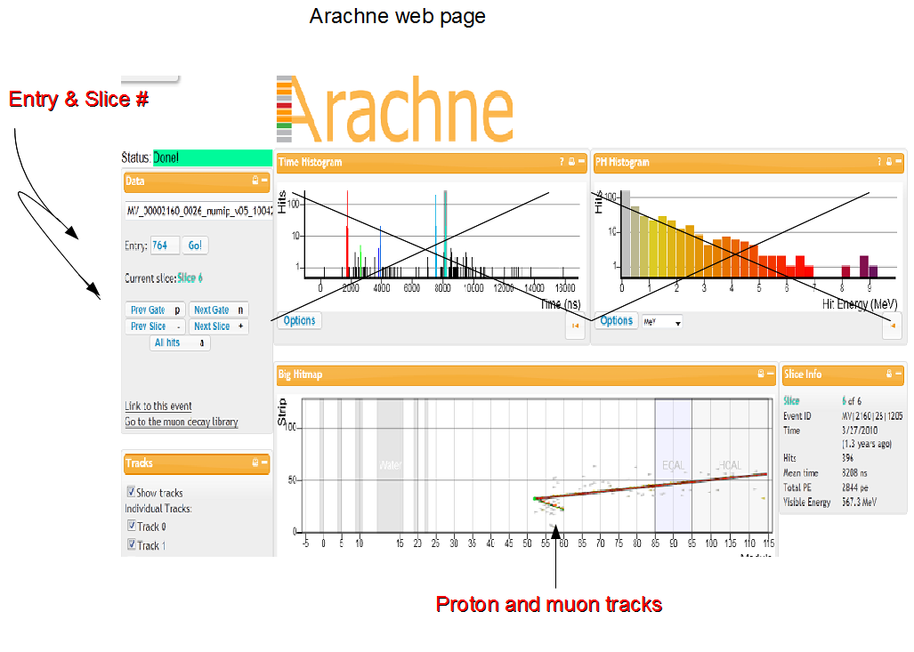
STEP 1 & 2

Arachne web page

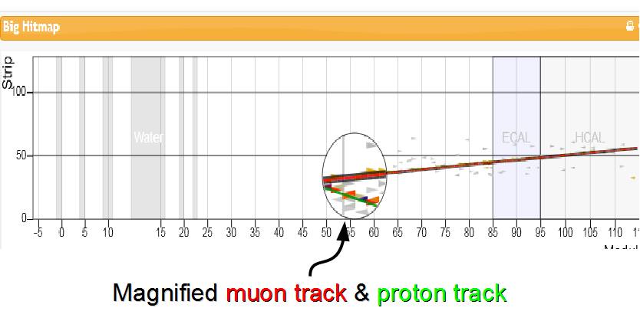
STEPS 3 & 4

Highlighting particle
tracks

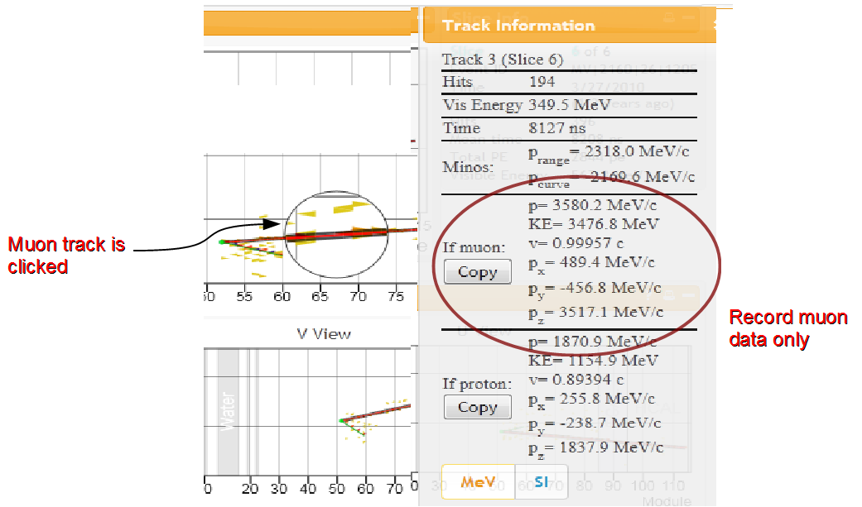
STEPS 4 & 5

Click on either of the tracks &
record matching
particle’s data

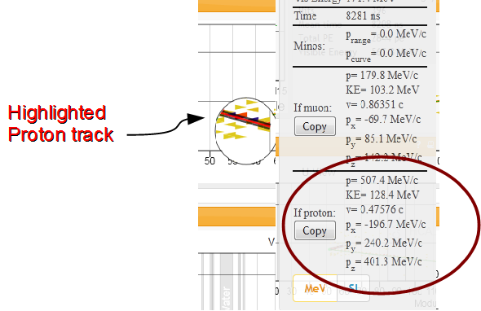
STEP 7:

Click other track (proton)
and record its data

MINERvA - Arachne Collection Sheet
Event |  | Muon  momentum |  |  | Proton momentum |  |  | Sum of momentum
Entry # | slice | p_{x} | p_{y} | p_{z} | p_{x} | p_{y} | p_{z} | p_{x} | p_{y} | p_{z}

ANALYSIS:

- Determine the smallest and greatest sum in momentum along the z-axis.

- How many of the sum of p_{x} and sum of p_{y} are positive and how many are negative?

- Why are the z-axis momenta always so much larger than either the x or y-axis momenta?

- Before the collision what was assumed about the momentum of the neutron along the x & y-axis?

b. Looking at the sum in momentum along the x & y-axis what must one now conclude about the
initial momentum of the neutron. Justify.

